
St James’ CE Primary School
Newsletter Issue 32
Our Vision is:



Within our community we strive to develop deep roots, strong growth and freedom to flourish as a unique and whole child of God.

Deep Roots Strong Growth Freedom to Flourish
Our vision is linked to Matthew 13 - The Parable of the Sower – ‘… but the seed falling on good soil refers to someone who hears the word and understands it. …….produces a crop, yielding a hundred, sixty or thirty times what was sown.”
Our Values are Kindness and Respect:
Autumn 1 : Responsibility  Autumn 2 : Friendship | Spring 1: Perseverance  Spring 2 : Trust | Summer 1: Courage  Summer 2: Positivity

Dates for your Diary
Swimming Lessons have started
for Yr4 (Every Tuesday)
Please ensure the children bring their kit in. a separate bag to school

Monday 10th June 2024
Yr2 visit to Mosque

All start Athletics Event
Lea Valley Athletics centre
If your child is attending you will have received a letter

Wednesday 12th June 2024
District Sports for selected pupils at Lea Valley Athletics Centre
if you child is attending you will have received a letter
Parents are welcome to watch from 1.30pm

Friday 14th June 2024
Yr1/2 Football event at Tottenham Training ground
if you child is attending you will have received a letter

A message from Mrs Everard
Dear All,
What a lovely return to school it has been this past week! It was so lovely seeing all the smiling faces back at school for our final half term this year- the time is certainly flying by! The children have begun looking at our new value positivity, we have discussed what it means to be positive and how this links to the changes that are about to happen, the end of this year group and the start of a new class or school and how being positive helps us manage our feelings.

We look at the story of Moses in the basket and how this story is full of sadness for his mother but that with hope and positivity, you can find joy in times of challenge. That just as this proverb says - ‘a cheerful heart is good medicine’. We looked at how having a positive view on life can change how we tackle dilemmas. We will continue looking at this value over the coming weeks and our Yr1 ambassadors for this value will do their assembly sharing what they have learnt about this value. Our prayer this week was:
Dear God, We ask that you help us be positive even when something is challenged. We know that your light guides us and that together as a connected community we can flourish, grow and learn. Amen
This term is full of challenges next week Yr4 and Yr1 will be challenged in showing their skill in timestables and in phonics - we know that they will flourish and shine as they have worked hard to grow in skills just as our vision reminds us of growing and flourishing as a community. We will also be welcoming the ‘hatching eggs next week in reception class as part of their growing unit - thank you if you supported by buying cakes! There are many events over the next few weeks - please keep reading the newsletters so that you keep up to date with everything going on!
God Bless, Mrs Everard and all the staff at St James’

Yr5 Champions


Celebration Superstars

Each week we celebrate children for their work in class or around the school as well as someone who has shown our ½ termly value. This term our value is courage.
Year 1 | Year 3 | Year 5
Aidan: for his super writing this week in English and showing his skills!  Olivia - for demonstrating positivity in her learning | Chidera: for making a. wonderful start to St James’.  Eliyza: for having a positive attitude to her learning in all areas of the curriculum | Kai: for working extremely hard on his handwriting and presentation and showing improvement in maths especially.  Natanya: for showing positivity in her action and words both in class and around the school.
We are so proud of you for your success in class - Congratulations!

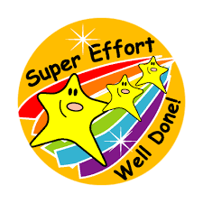

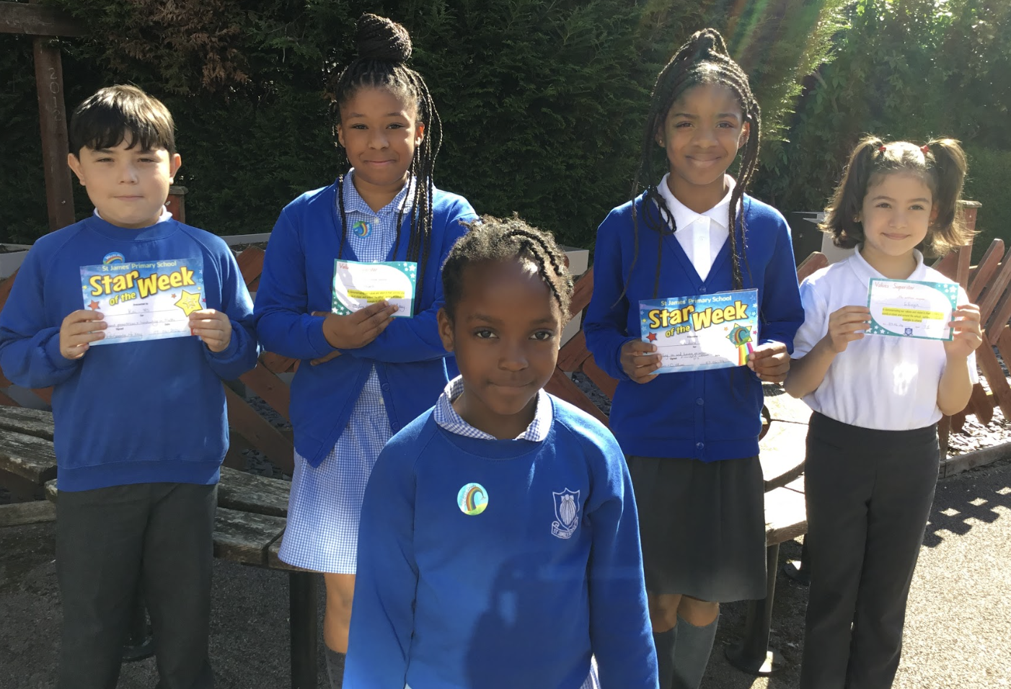


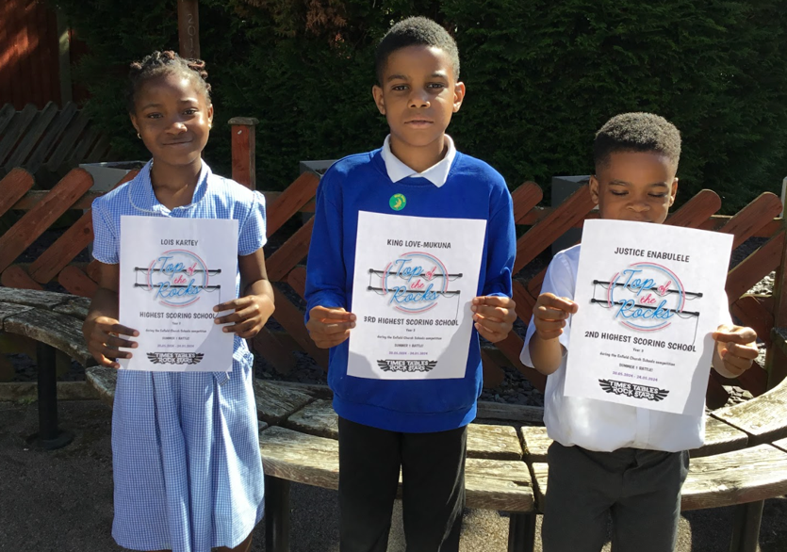
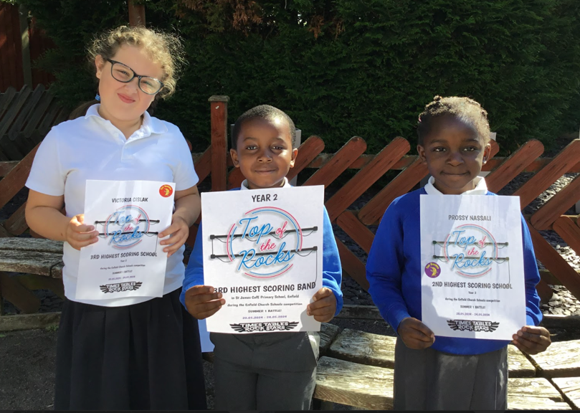

Highest score overall: 3rd: King 2nd Justice 1st Lois


Highest score overall: 3rd: Victoria 2nd Prossy 1st Eli

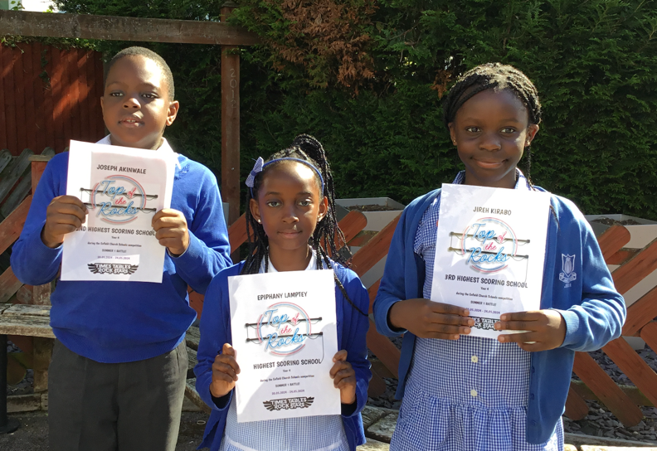
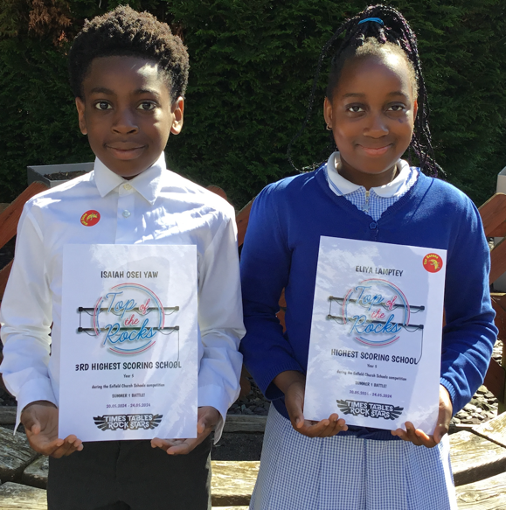

Highest score overall: 3rd: Sahsine 2nd Georgio 1st Seanna
Highest score overall: 3rd: Joseph 2nd Justice 1st Epiphany
Highest score overall: 3rd: Isaiah 2nd Ronald 1st Eliya


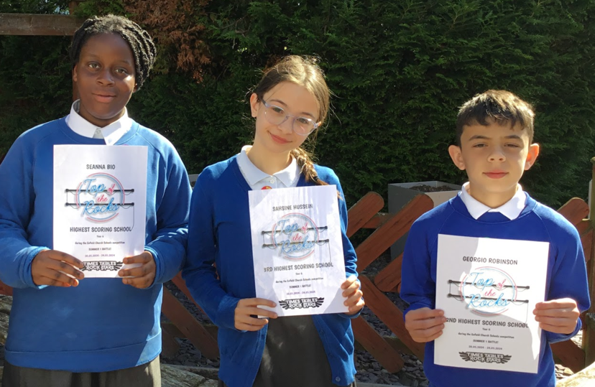


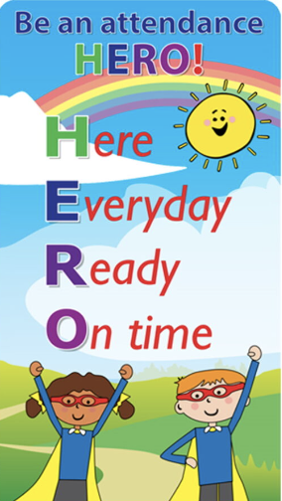

YR | Yr1 | Yr2 | Yr3 | Yr4 | Yr5 | Yr6
94% | 90% | 97% | 88% | 98% | 95% | 95%
A very mixed picture this week - Only 4 classes managed to get into the Green Zone - so well done to Yr2,yr4,5, & 6. Being at school, learning, flourishing is so important - Children MUST be at school - so let’s try and challenge ourselves to get all classes in the green Zone as many times as possible this term!
REMINDER OF TIMIMNGS
Main Gate opens at 8.35am
School Gate at 8.40am
ALL CHILDREN SHOULD BE IN CLASS BY 8.45AM
Collection Time:
Reception & KS1 (Y1/2) : 3.15PM
KS2 (Y3/4/5/6) : 3.20PM

Please be on time to collect your child!

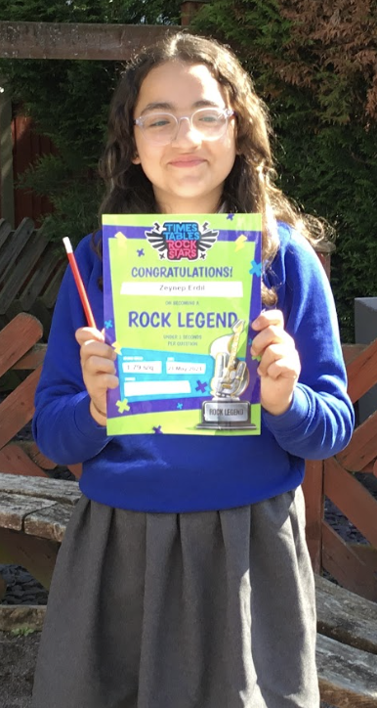
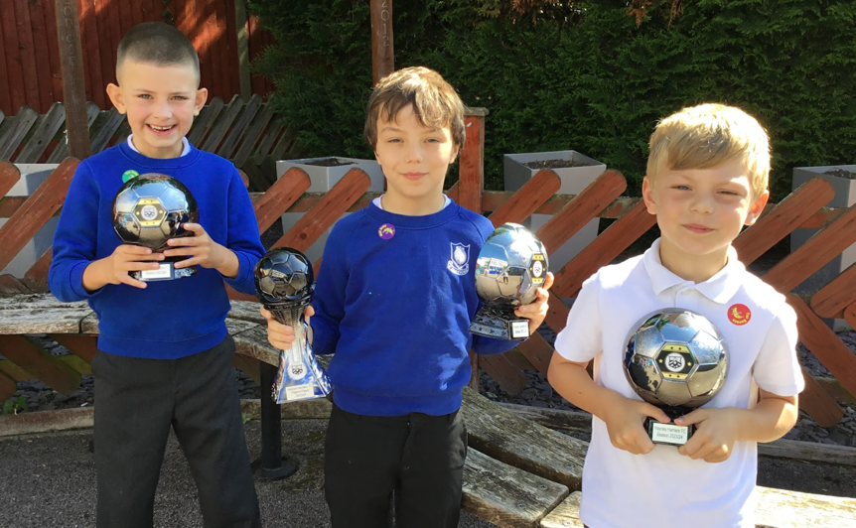

Claye, Ethan and Wojciech - shared their football awards from their club to the school - they achieved this for playing in the team this season and Claye got awarded the players trophy as well!
So pleasing to see our children flourishing outside of school too!

Congratulation to
Zeynep(Y6) who is now Rock Legends
She can answer the questions in under 2 seconds

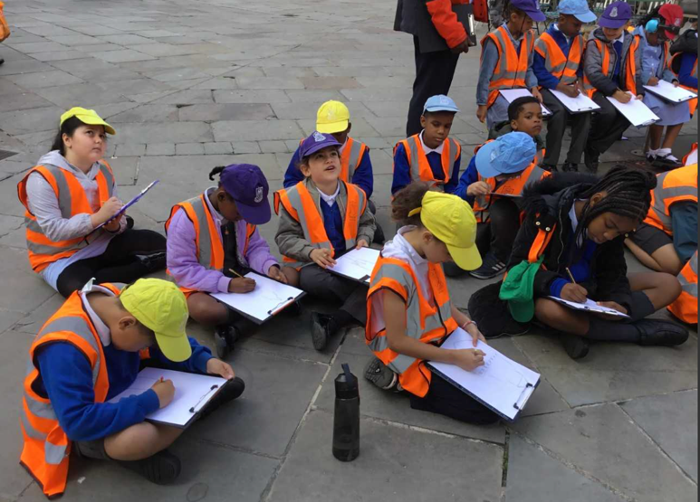
Thankfully the weather was finally nicer and Yr3 managed to complete their local history unit by visiting ‘Eleanor Cross Monument. They have been learning about why Waltham Cross has one of the twelve statues. They sketched and learnt about why it has a cross in the center of town.
The twelve Eleanor Crosses, including the one at Waltham, were erected in memory of Eleanor of Castile, queen of Edward I, who died in 1290.

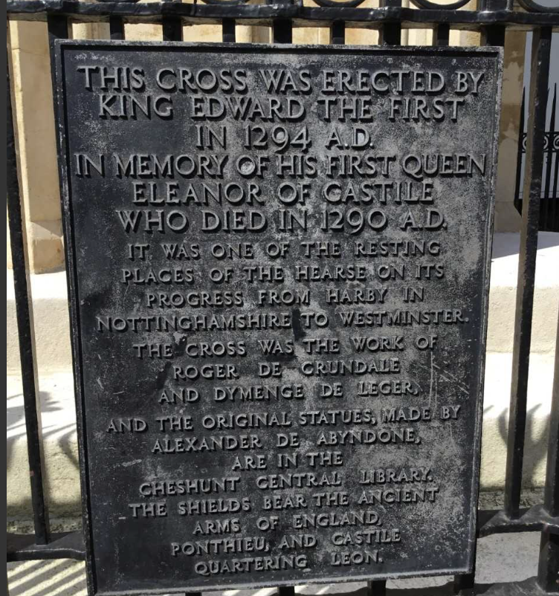
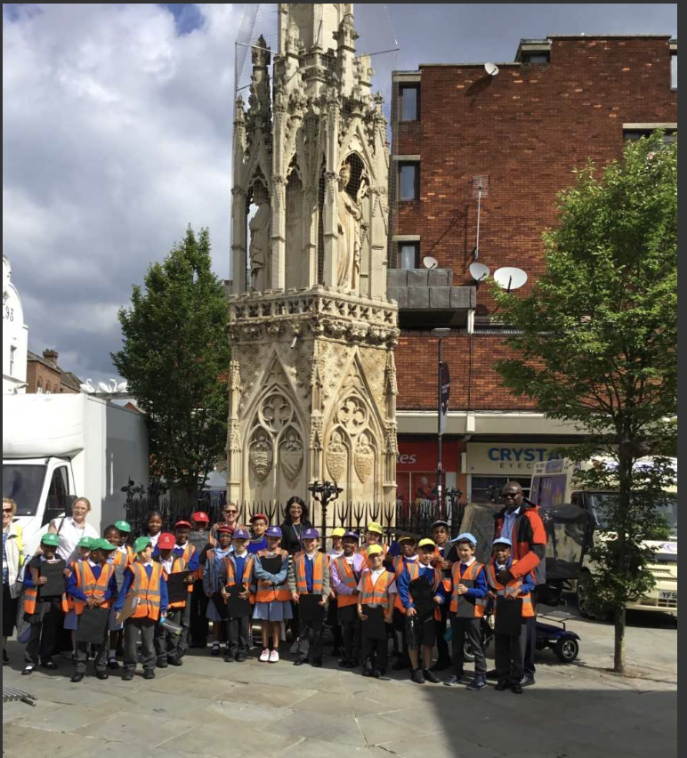
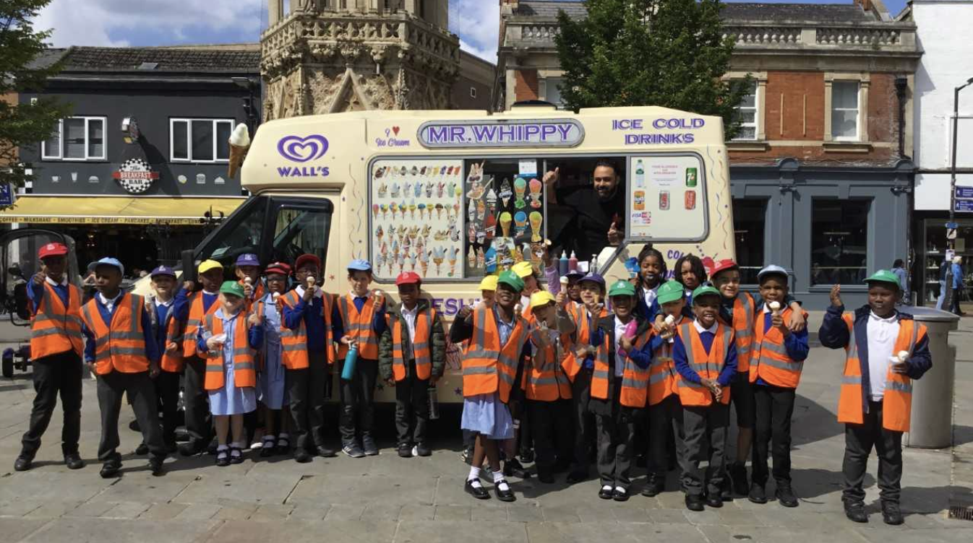
They also had a wonderful ‘treat’ from Mr Whippy’ the ice-cream
owner, who gave yr3 a free Ice-cream. Thank you!

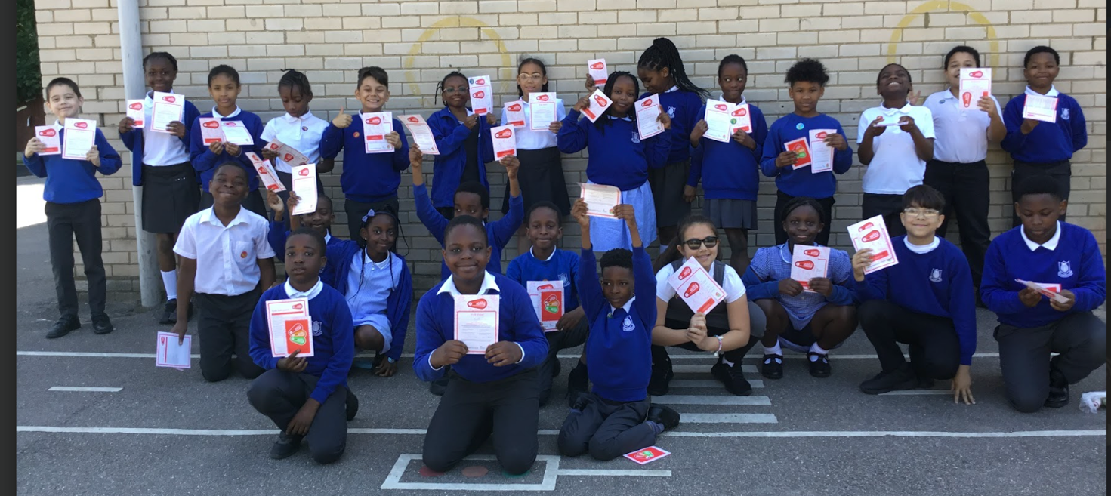
Year 4 recently took part in Bike training and the children achieved their
bikeability Level 1 certificate! This is to show that they can ride safely, use their brakes, and control the bike when turning.
Congratulations to all the children on showing their cycling skills!

