
Year 5 Autumn Term 2025
Welcome back to school, here is a letter detailing what your child will be learning this term, which will help you support them at home.

English  At the start of each unit children are asked to write a cold task which is unsupported work based on the unit and by the end of the unit they will have a hot task implementing all the different skills learnt in the lessons leading up to it.      At the start of the term in writing we will be completing a Biography on Barak Obama. Children will be researching parts of his life and the impact he has had. This will then culminate in writing a biography for him.  Later in the term we will be writing a letter from the point of view of Bradley Chalkers, a boy from our class story ‘There’s a boy in the girls’ bathroom’.    During SPaG lessons children will be covering a range of grammar objectives including: verbs, adverbs, noun phrases and relative clauses. We will also be expanding the children’s range of punctuation, particularly looking at commas, hyphens, brackets, semi colons and colons.  Children will use these writing skills to produce a range of written end pieces. They start each writing piece with a cold task, then we teach and learn skills to improve and then the children complete a hot task - this will show the progress they have made.    In class we will be reading a class book daily, taking part in guided reading sessions and practising reading skills (VIPERS) within our English and Reading lessons.  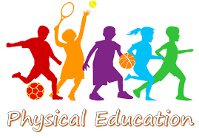  We have PE every Tuesday and Friday.  Indoor PE - Tuesday  Shorts+ blue T-shirt  Outdoor - Fridays  Shorts+ blue t-shirt, joggers or jumper will be needed in the colder weather. | Mathematics  This term our main teaching units will be  - Number and Place value- reading, writing, and comparing numbers to one million and determine the value of each number  - Addition, subtraction, multiplication and division of up to 4-digit numbers  - Solve problems involving these calculations  - Solve problems that involve area and perimeter  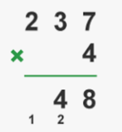  - Roman numerals  - Powers of 10 (10, 100, 1000)  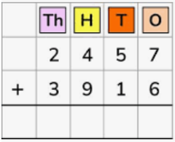  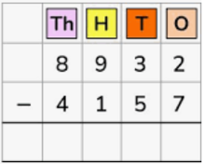  In our arithmetic sessions with Mrs Everard on a Tuesday we will be focussing on adding, subtraction and multiplying in the column method    Times Table Rock Stars is a fun and challenging programme designed to help pupils master the times tables.  Your child has a login and password and they should do daily practice on this programme.    Reading  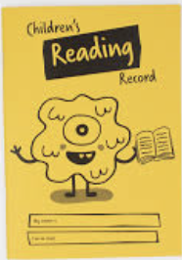  Children will have a reading book and diary and will be expected to read daily and write comments and this will be checked by us daily. This is their job- children are expected to write a comment of what is happening in the part of the book they have just read.  Their Reading Book and Diary MUST come to school each.
Music    We use ‘Music Express’ to teach this curriculum. This term the children will be studying ‘at the movies’ and music that links to films and then exploring music within the comnmunity and cultural influences.  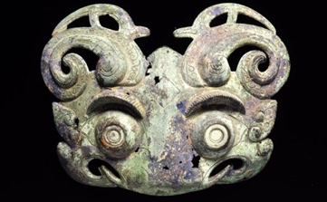  In Art and Design, the children will be exploring Taotie motifs – fascinating symmetrical designs found on ancient Chinese bronze vessels. They will learn about the history and cultural significance of these patterns, before experimenting with creating their own versions using drawing and craft techniques. This unit gives the children the chance to develop their artistic skills while also gaining an appreciation of how art can reflect beliefs and traditions from the past. | 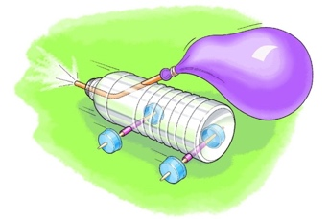  DT  In our Design and Technology unit, children will be learning all about pneumatic systems – mechanisms that use compressed air to create movement. They will explore how air can be used to exert force and investigate different ways these systems are applied in real life, from everyday objects to machines. Through hands-on projects, the children will design and build their own pneumatic models, giving them the chance to be creative while developing problem-solving and engineering skills.
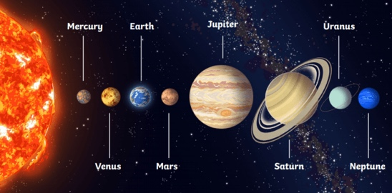
Science
Earth and Space
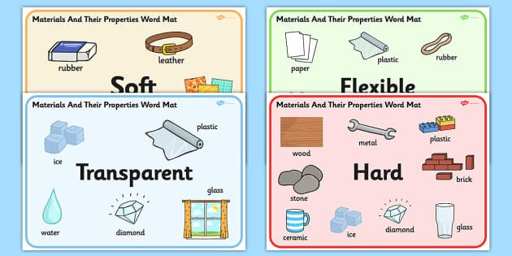
In this module, children will be exploring our solar system. They will learn how the Earth and other planets move around the Sun, how the Moon orbits the Earth, and why we experience day and night. The children will also discover that the Sun, Earth, and Moon are spherical bodies and develop an understanding of the apparent movement of the Sun across the sky.
Properties and uses of materials
compare and group together everyday materials on the basis of their properties, including their hardness, [solubility,] transparency, conductivity (electrical and thermal), and response to magnets
give reasons, based on evidence from comparative and fair tests, for the particular uses of everyday materials, including metals, wood and plastic.


Geography
Our topic this half term is …‘What’s so special about the USA?’
During this unit children will learn about:
How and why America is divided up into states.
The impact of hurricanes, earthquakes and tornadoes and where they are likely to happen.
8 point compass points.
The impact and meaning of urbanisation.
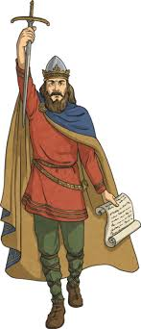
History
In autumn 2, we will be using our historical skills to answer the question, ‘Who were the Anglo-Saxons and Vikings and were they similar or different?’

During this unit children will learn about:
The differences between, raiders, invaders and settlers.
Where the Anglo-Saxons and Vikings came from.
Who was in Britian before them, when did they arrive, why did they come?
All about Viking homes
The religious beliefs of Anglo-Saxon England.

RE  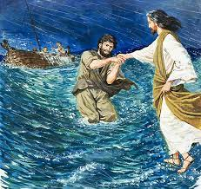  We will be learning about the meaning of miracles. They will be reminded about the different miracles cited in the Bible. The children will explore what miracles mean to Christians. They will also be thinking about how they can apply this to their own daily lives and the wider community. We will also be thinking about our big questions ‘What can we learn from wisdom?’  Then in Autumn 2, we will be looking art and Christmas and how the two combine together and how art can tell the story, explain a message or symbol. We are also responsible for leading the Carol Service in Church as part of the Christmas activities. Further details will be shared nearer the time.  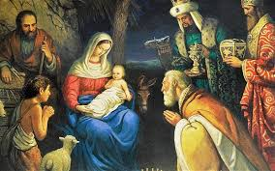 | 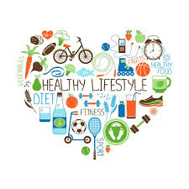  PSHE  We are looking about how we live a healthy lifestyle, looking at healthy food, exercises and the effects of smoking on the body.  We will also be looking at Peer pressure and how we can make our own informed choices.  Computing  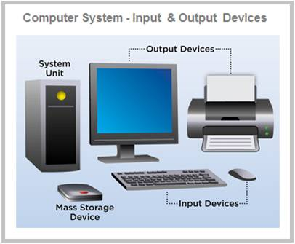  In Computing, the children will be developing their understanding of computer systems and how information moves between different devices. They will explore both small-scale and large-scale systems, learning to explain how inputs, processes, and outputs work in real-world examples. The children will also discover how information is found on the internet, including how search engines select and rank results, what influences searches, and how different search engines can be compared.
If you do wish to contact me, please do call the office and leave me a message or email the school office on: Email: sbm@st-james.enfield.sch.uk, or you are welcome to speak to me at the end of the day, I am not hard to find.
Here is to the year ahead and working with you and your child. I hope that this information has been very useful.
Mr Kay and the Year 5 team.

