
St James’ CE Primary School
Newsletter Issue 24
Our Vision is:



Within our community we strive to develop deep roots, strong growth and freedom to flourish as a unique and whole child of God.

Deep Roots Strong Growth Freedom to Flourish
Our vision is linked to Matthew 13 - The Parable of the Sower – ‘… but the seed falling on good soil refers to someone who hears the word and understands it. …….produces a crop, yielding a hundred, sixty or thirty times what was sown.”
Our Values are Kindness and Respect:
Autumn 1: Responsibility  Autumn 2: Friendship | Spring 1: Perseverance  Spring 2: Trust | Summer 1: Courage  Summer2: Positivity
Dates for your Diary
Spring Term Clubs
Monday 8am Girls Netball Yr4/5/6
Tuesday Recorders Yr3/4/5/6
Knitting &Crochet Yr3/4/5/6
Wednesday – Gymnastic Club Yr3/4/5/6
Friday 8am Girls Footie Club Yr3/4/5/6
Friday -Football Club Yr3/4/5/6 (4.30pm)
ALL CLUBS FINISH AT 4.20PM

Wednesday 18th March 2026
Yr3 Geography trip to Enfield Town Park

Thursday 19th March 2026
Kurling competition for London Youth Games
Dance festival for Year 3 and Year 6 at Millfield theatre - Pick up at 8.15pm at the theatre
Friday 20th March 2026
Year 3/4 Girls Football tournament
(If your child is selected you have received a letter)

Tuesday 24th March 2026
Yr3 Class assembly at 9.10am

Thursday 26th March 2026
Easter Service at church 9.10am – all families’ welcome

Friday 27th March 2026
Last day of term – school finishes at 1.30pm

School returns on Monday 13th April at 8.40am or for breakfast club

A message for Mrs Everard
Dear All,

The weeks are flying by and soon Easter will be upon us! This week we have had so many amazing opportunities to learn. The week started with a visit from our EWO (Educational welfare officer) who looks at our attendance. We are doing really well and we are so pleased that so many of our children have good attendance. We now need to ensure that as the weather gets warmer and the winter bugs disappear, all our children are in school every day! Thank you if you are a family that is doing well with attendance; being in school, learning, socialising with friends, building these vital skills is what will really help your child succeed in later life!


We have had many events this week – Year 4 attended a hockey experience, the weather was lovely and they learnt new skills and tactics to improve their hockey play and they had a great time. Year 5 also went out this week, as part of their RE learning and took part in the ‘Easter Experience’ where they investigated the events during Holy Week, they also got the opportunity to visit Enfield Town Library and learn about how they can use the library to support them at school. Please take a look within this newsletter for more details on both visits. We also had two footballing events, with the celebration of ‘Girl’s football’ – where girls from KS2 attended a festival of footballing at Bishops and Mr. Kay took some Year 5 children to a football experience at Enfield Grammar.

This week in worship we focused on ‘Peace’, what it means and how this links to the lives we live. We discussed how we can have peace in our lives through our friendships and connections, but we also spoke about how we can encourage the world to find peace and that living in harmony with each other is just what Jesus taught us. We also this week welcomed Reverend Annie, who lead our worship on Thursday and looked at the prayer and song ‘Make me a channel of your peace’ and how this tells us to love, faith, hope, peace. Our bible quote this week was: "My dear brothers and sisters, take note of this: Everyone should be quick to listen, slow to speak and slow to become angry". James 1:19

Wishing you a wonderful and blissful weekend, with hopefully more sunshine, showing us that Spring is finally beginning to shine!
God Bless you and your family during the season of lent.
Mrs Everard, and all the team at St James’

Yr5 Champions

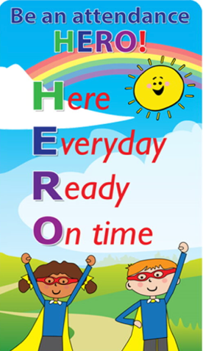


YR | YR1 | Yr2 | Yr3 | Yr4 | Yr5 | Yr6
86% | 91% | 96% | 95% | 95% | 99% | 97%
Well, done to Yr2, Yr3, Yr4, Yr 5 and Yr6 for maintaining attendance in the Green zone!
There are some sickness illnesses around, that are causing some unwellness and we are using hand sanister to try and avoid the spread, but please try to encourage your child to do the following:
Putting tissues in bins, covering their mouth and nose with their hand when coughing and sneezing, washing hands especially after going to the toilet and the importance of wearing a coat to school- so please help us keep your child healthy!
If your child is sick, please follow guidelines and keep them home to avoid spreading it.

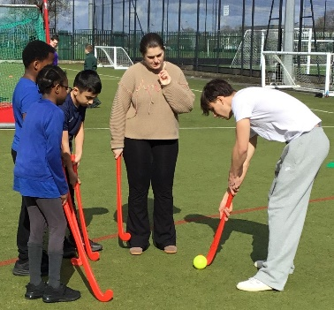

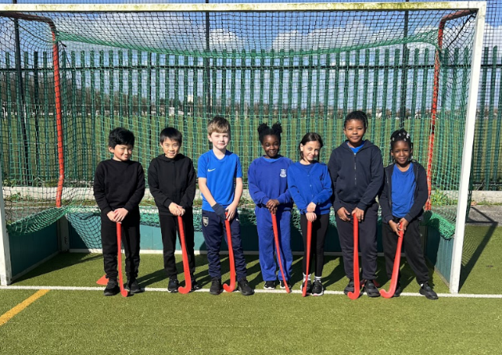
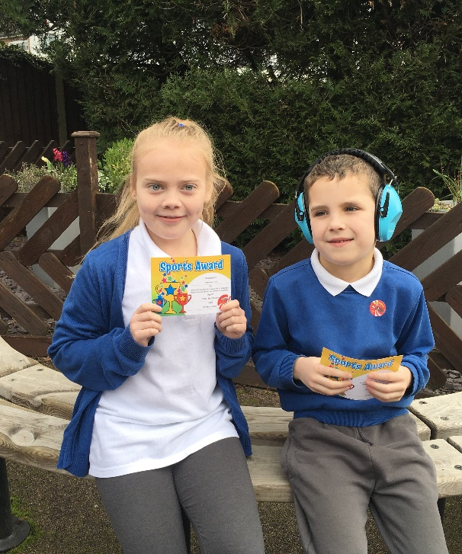

Congratulations to Penelope (Yr5) for her skill and enthusiasm in their Dance lesson this week. Well done also to Filip (Yr1) for his amazing ball skills and growing independence in PE
Year 4 attended a hockey experience led by Enfield PE Team & Kingsmead school, they learnt skills involving defending and attacking – it was a great afternoon!

Each week we celebrate children for their work in class or around the school as well as someone who has shown our ½ termly value. This term our value is courage.
Nursery | Year 1 | Year 3 | Year 5
Esther  Always setting a fantastic example to others & being ready to learn | Kamiyah  Being a superstar in class | Amy  Always being kind & considerate member of Year 3 - keep on shining bright | Joel  Being an amazing example oat the Easter trip
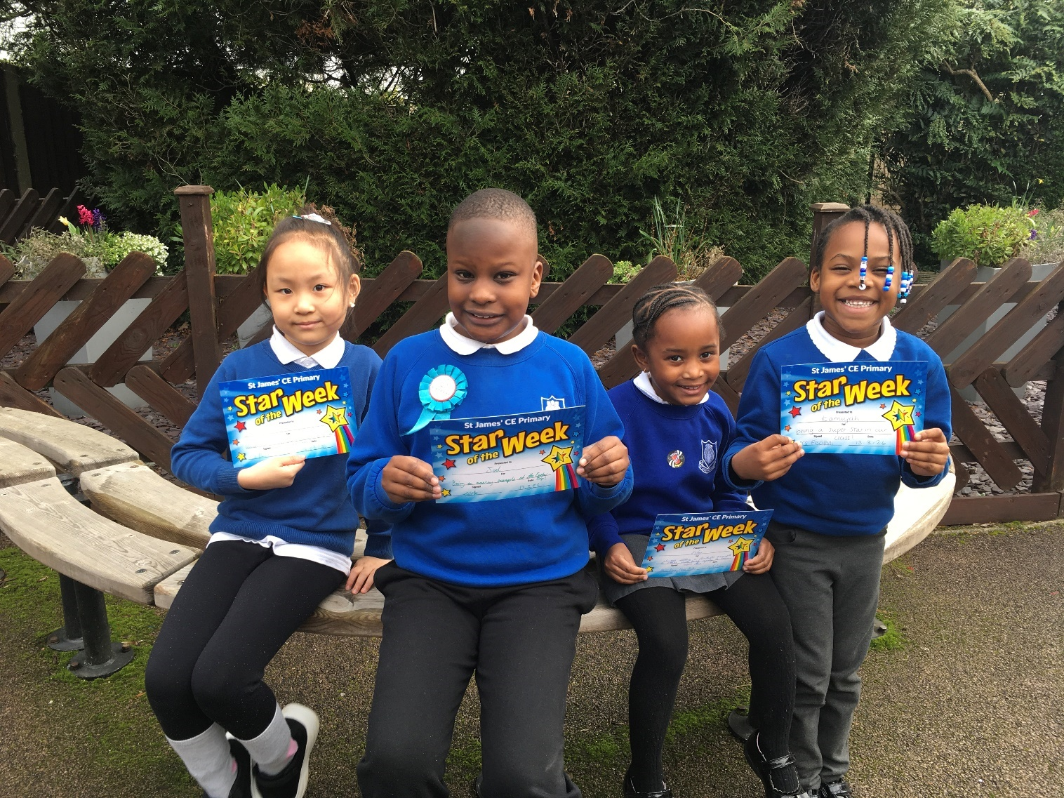
We are so proud of you for your success in class - Congratulations!


Celebration Superstar







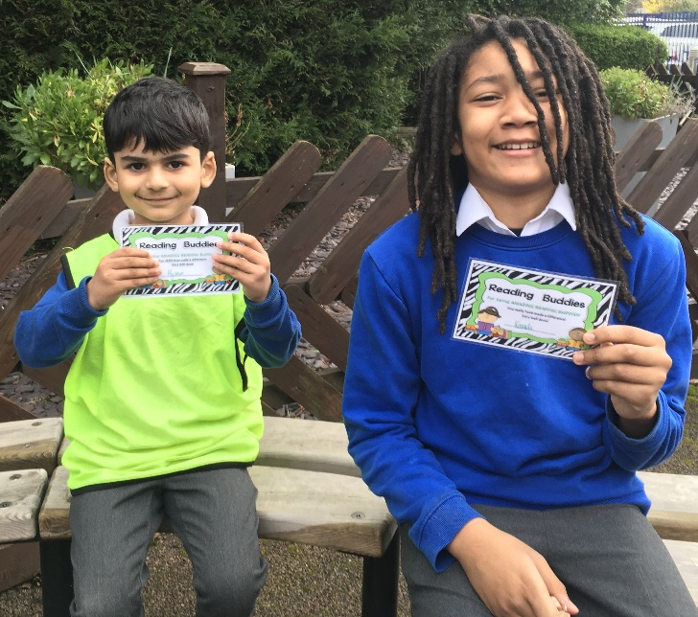
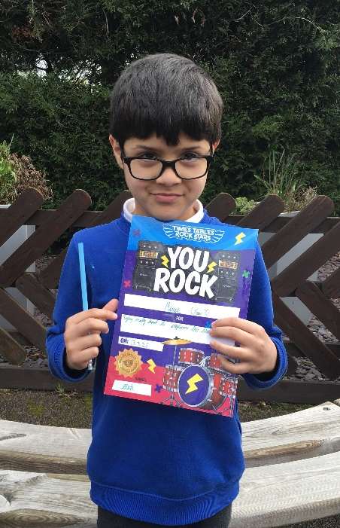

Well done to Kavali (Yr5) for a fantastic job as a reading buddy to Hyusein in Reception Class.
Congratulations to Mueez (Yr 3) for a huge improvement in his recall and speed on TTRS



Maths Superstar
Little Wandle phonics Superstar


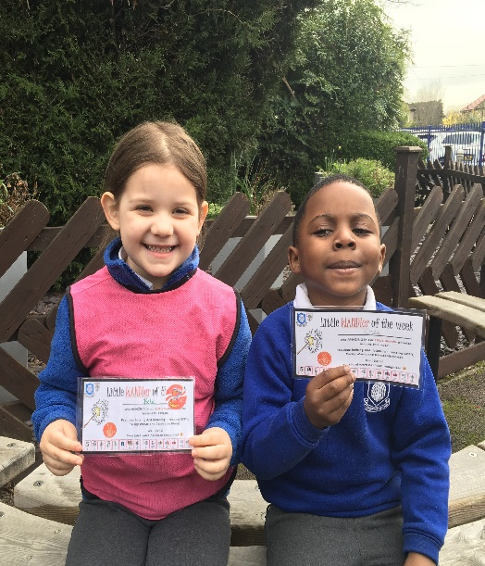

Congratulations to Ezekiel (Yr1) on his amazing Maths work on partitioning numbers and understanding tens and ones! Great Maths – well done
Congratulations to Bela (YrR) & Ena (Yr 1) who are working really hard in their phonics & reading sessions and with their class sounds this week!


Values Ambassadors
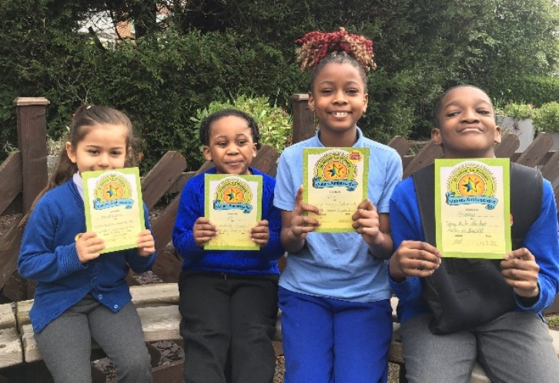

Values Ambassadors

Big Walk and Wheel – is a national week that inspires pupils to make active journeys to school, improve air quality in their neighbourhood and discover how these changes benefit their world.
We would love everyone to walk, wheel, scoot and cycle to school so we can log as many active journeys as possible.

Congratulations to Madalina (Yr1), JJ (Yr N), Esther (Yr3), Giovanni (Yr5) who are doing a wonderful job demonstrating the St James school values.

Year 3 visit to Southgate Synagogue
Year 3 had a great visit to the Southgate Synagogue. It was incredibly helpful for the children to see inside the synagogue and the amazing scrolls and other items.
The ladies at the Synagogue explained life in a Jewish family and showed how the Shabbat meal works. The children were offered tasters of bread and grape juice if they wanted.
The visit has meant a lot to the children, especially in understanding more of the Jewish culture and faith.

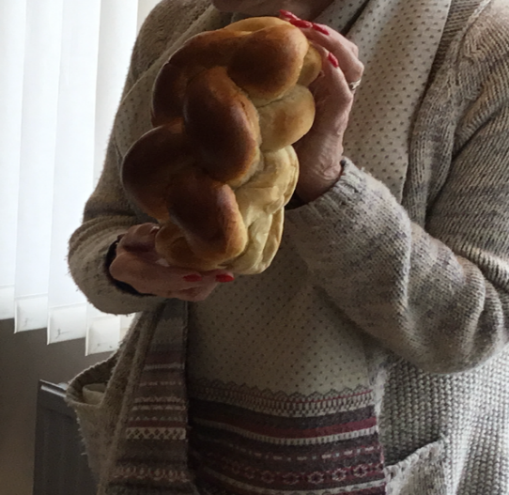
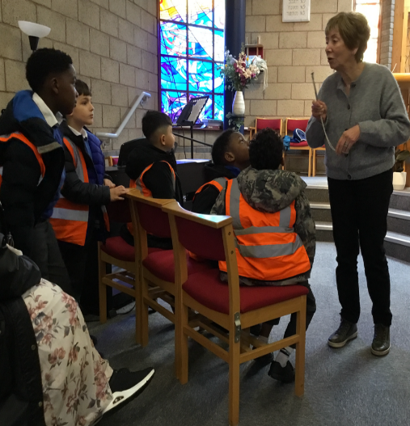

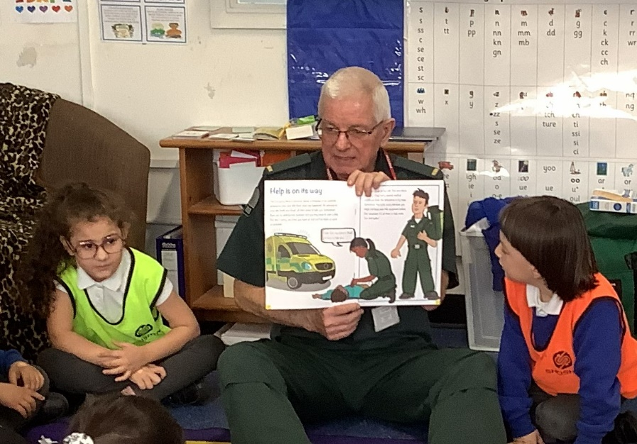
Paramedic Paul visits Reception Class

This week, Reception & Nursery class had a visit from Miss Bate's dad, Paramedic Paul. They did a fantastic job learning all about the role of a Paramedic and what to do in an emergency, including the recovery position and calling for help. Well done EYFS!


Year 5 had a wonderful opportunity to visit the Baptist Church in Enfield Town as part of the Easter Experience. During their visit, the pupils interacted with key characters representing this impactful narrative, including Pontius Pilate's wife, a Roman Centurion, Mary Magdalene, and Peter the disciple. This unique experience provided our students with valuable insights into the
perspectives of these individuals, enhancing their understanding of the emotional and historical context surrounding Easter. The level of engagement and curiosity demonstrated by the children was commendable. They left the church with a deeper appreciation for the themes of sacrifice and redemption, reflecting on how these ideas resonate in their own lives. We also visited the library and choose some new books.

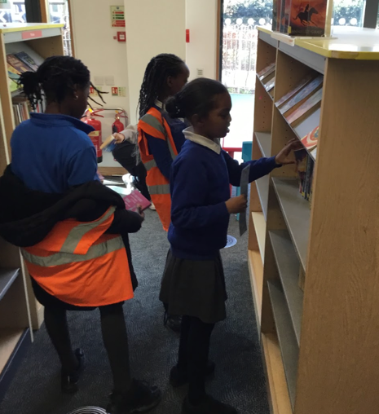
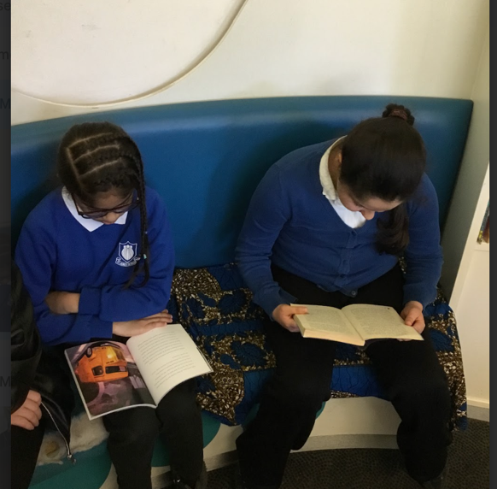
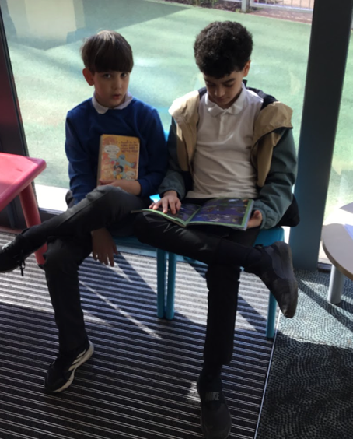
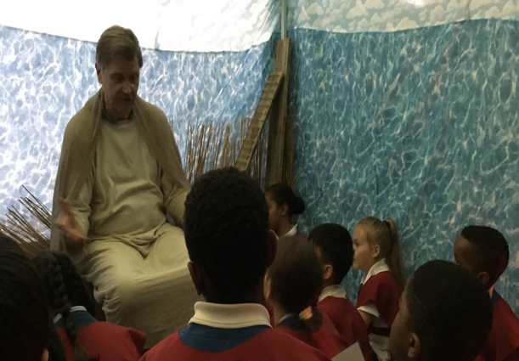
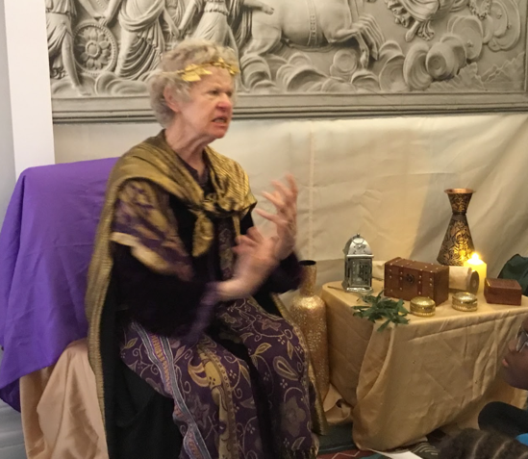
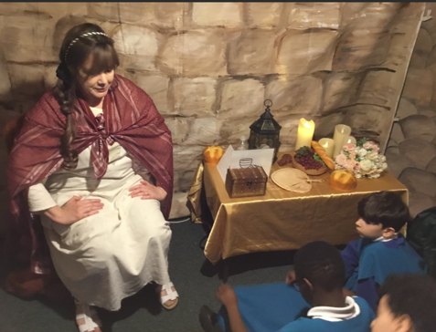

Year 5: Easter Experienc e
Online Learning Zone!

